Europe day - find the word
- _________

- _____ _____

- _________

- _____ ______

- ____ ______ _____

- ____ ______

- ______ _____

- __________ ______

- ______ __ _____

- ___________ ____

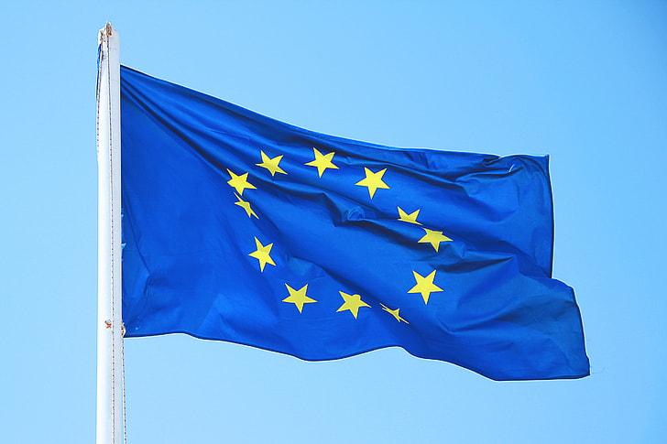
Europe day - find the word
- _____s___

- _t___ _____

- __r______

- _____ _a____

- ____ ______ ___s_

- b___ ______

- ______ _o___

- _______u__ ______

- ______ __ ____r

- __________g ____

